ASSIGNMENT - 01

Popular HTTP Libraries Across Programming Languages and Their Role in HTTP/1.1 (RFC 7230)

1. Introduction
The Hypertext Transfer Protocol (HTTP) is what makes it possible for communication to take place on the internet. The description of how the data exchange takes place over HTTP/1.1 can be found in RFC 7230. Developers do not have to implement this protocol by themselves, because there are HTTP libraries that will do that.
This means that HTTP libraries become the actual implementation of HTTP/1.1 protocol.

2. Popular HTTP Libraries in Different Programming Languages
There are various libraries for making HTTP requests in different programming languages. While some are native libraries, there are other third-party libraries as well.
- Python


- Requests - the most common and easy to use HTTP client library
- urllib / urllib3 – lower level tools
The Requests library makes HTTP easy to use by mapping everything into Python objects and handling cookies, headers and SSL automatically.


2. Java
- Java HttpClient (inbuilt in Java 11+)
- OkHttp – popular and high-performance HTTP client
These libraries allow you to make both synchronous and asynchronous HTTP calls.

3.JavaScript (both browser and node.js)


- Fetch API – inbuilt browser API
- Axios – common promise based HTTP client
- node-fetch and Got
- Axios supports features such as request interception and automatic JSON transforms.


4. Ruby
- Net::HTTP – built-in
- http.rb – modern and flexible
- httpclient
Some of these libraries (http.rb, for instance) do native HTTP parsing to achieve better performance.

5. PHP

- Guzzle – the most popular HTTP client
- cURL (extension)
- Symfony HTTP Client
Guzzle is known to handle requests and errors using middleware.

6. C# (.NET)

- HttpClient – built-in modern HTTP client
- RestSharp
Popular among enterprise applications as an API integration tool.


7. Go
- net/http – standard library
Famous for its simplicity, performance, and concurrency abilities.

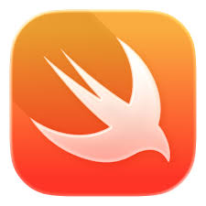
8. Swift

- URLSession – built-in
- Alamofire – popular library
Utilized by iOS and macOS applications in their network programming code.

9. Rust

- reqwest – the most popular HTTP client
- hyper – lower-level HTTP library
Provides asynchronous operations and various safety features.

10. Perl

- LWP (libwww-perl)
- HTTP::Tiny
An older language which is still actively used.

3. How HTTP Libraries Implement HTTP/1.1 (RFC 7230)

HTTP client libraries provide the implementation of the HTTP/1.1 protocol, handling:
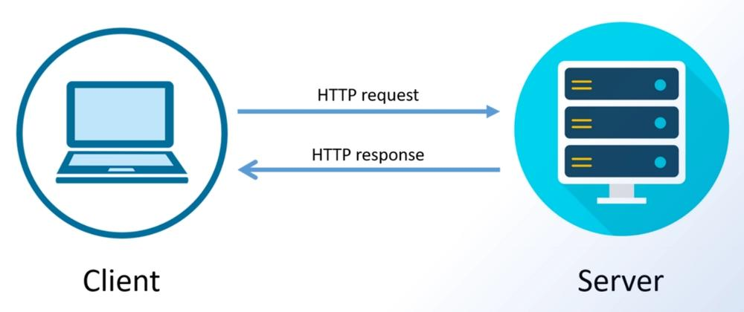
Primary Functions
- HTTP requests creation
  - Generate HTTP requests: GET, POST, PUT, DELETE
  - Include headers, URL parameters, and message bodies
- Messages formatting
  - Following HTTP/1.1 message format (start-line, headers, body)
  - Providing proper encoding and formatting
- Handling of the connection
  - Implementing persistent connections (keep-alive)
  - Dealing with sockets and TCP transport layer
- Response parsing
  - Processing of status codes (200 OK, 404 Not Found, etc.)
  - Reading headers and body
- Handling of errors
  - Identifying network problems, timeouts, and improper responses
- Handling security protocols
  - Implementation of HTTPS (secure socket layer TLS/SSL)
  - Supporting authentication methods (Basic, bearer tokens, API keys)
In summary, these libraries simplify the complex requirements defined in RFC 7230 into simple functions for easy implementation.

4. Example: Python Requests Client



The Requests library for Python is one of the best implementations.
Why Python Requests is Popular
  - Easy and clean syntax
  - Automatic handling of:

- o-Headers
- o-Cookies
- o-Converting JSON objects
- o-SSL certification

5. Example Code

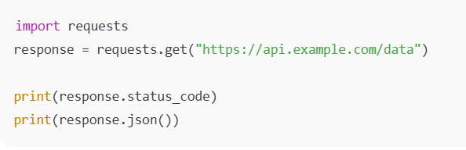
6. Advantages for Developers


- Easier Interaction with HTTP
  - The developer writes only one line instead of managing the socket themselves
- Data Parsing
  - Parses JSON into Pythonic object
- Session Tracking
  - Uses cookies in all queries
- Exception Handling
  - Creates specific exception classes for failure cases
- Protocol Layering
  - Uses other libraries for protocol implementation
7. Conclusion

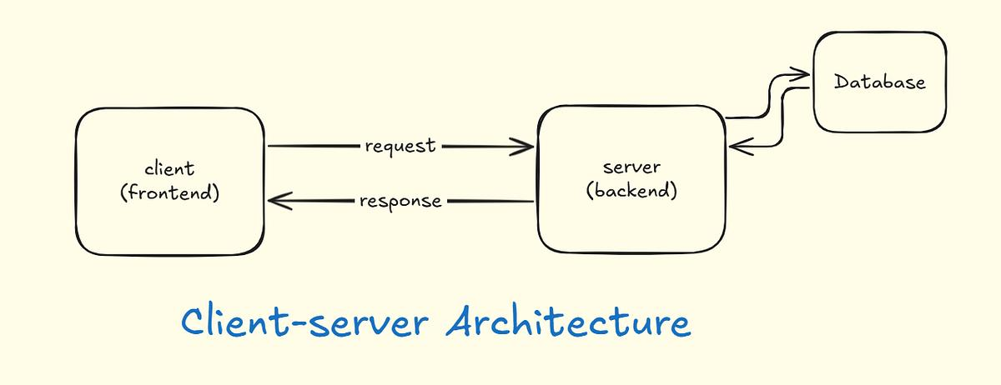
HTTP libraries are an indispensable tool that serves as a connector between developers and HTTP/1.1 protocol (RFC 7230). They provide a simple API for easy interaction with the web server on top of the implemented HTTP protocol.
- All languages have their HTTP libraries
- Libraries internally implement HTTP protocol
- Their use makes web interaction easier
- Common examples include Request, Axios, Guzzle, and HttpClient

